**Lab Cycle 3**

**Demonstrate creating various types of charts and plots using functions in mathplotlib library**

1. **Sarah bought a new car in 2001 for $24,000. The dollar value of her car changed each year as shown in the table below.**

**Value of Sarah's Car**

**Year Value**

**2001 $24,000**

**2002 $22,500**

**2003 $19,700**

**2004 $17,500**

**2005 $14,500**

**2006 $10,000**

**2007 $ 5,800**

**Represent the following information using a line graph with following style properties**

* **X- axis - Year**

**Y –axis - Car Value**

* **title –Value Depreciation (left Aligned)**
* **Line Style dashdot and Line-color should be red**
* **point using * symbol with green color and size 20**

**Subplot() provides multiple plots in one figure.**

import matplotlib.pyplot as plt

import numpy as np

xpoints = np.array([2001,2002,2003,2004,2005,2006,2007])

ypoints = np.array([24000,22500,19700,17500,14500,10000,5800])

plt.plot(xpoints,ypoints,'-.r',marker ='*' ,ms=20, mec="g", mfc ='g')

plt.title("valuedeprection",loc="left")

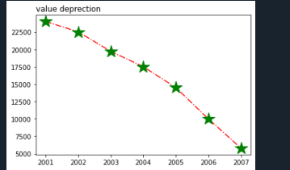

**2.Following table gives the daily sales of the following items in a shop**

|  |  |  |  |  |  |
| --- | --- | --- | --- | --- | --- |
| **Day** | **Mon** | **Tues** | **Wed** | **Thurs** | **Fri** |
| **Drinks** | **300** | **450** | **150** | **400** | **650** |
| **Food** | **400** | **500** | **350** | **300** | **500** |

**Use subplot function to draw the line graphs with grids(color as blue  and line style dotted) for the above information as 2 separate graphs in two rows**

1. **Properties for the Graph 1:**

* **X label- Days of week**
* **Y label-Sale of Drinks**
* **Title-Sales Data1 (right aligned)**
* **Line –dotted with cyan color**
* **Points- hexagon shape with color magenta and outline black**

1. **Properties for the Graph 2:**

* **X label- Days of Week**
* **Y label-Sale of Food**
* **Title-Sales Data2 ( center aligned)**
* **Line –dashed with yellow color**
* **Points- diamond shape with color green and outline red**

import numpy as np

import matplotlib.pyplot as plt

#plot1

x= np.array(['mon','tue','wed','thur','fri'])

y = np.array([300,450,150,400,600])

plt.subplot(2,1,1)

plt.plot(x,y,color ='cyan', linestyle='dotted',marker ='h' ,ms=20, mec="black", mfc ='m')

plt.grid(color ='green', linestyle='dotted')

plt.title("sales data 1",loc="right")

plt.xlabel("days of week")

plt.ylabel("drinks")

#plot2

x= np.array(['mon','tue','wed','thur','fri'])

y = np.array([400,500,350,300,500])

plt.subplot(2,1,2)

plt.plot(x,y,'.-y',marker = 'd',ms=20,mec='r',mfc='g')

plt.grid(color ='green', linestyle='dotted')

plt.title("sales data2",loc="right")

plt.xlabel("days of week")

plt.ylabel("foods")plt.subplots_adjust(top=2.5,

bottom=1.5,

wspace=0.4,

hspace=0.4 )

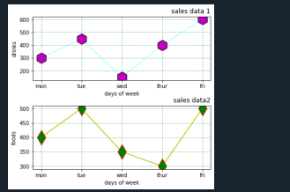

**3.Create scatter plot for the below data:(use Scatter function)**

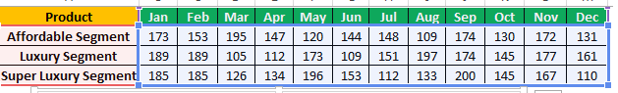

**Create scatter plot for each Segment with following properties within one graph**

* **X Label- Months of Year with font size 18**
* **Y-Label- Sales of Segments**
* **Title –Sales Data**
* **Color for Affordable segment- pink**
* **Color for Luxury Segment- Yellow**
* **Color for Super luxury segment-blue**

import matplotlib.pyplot as plt

import numpy as np

z=np.array(['jan','feb','mar','apr','may','jun','jul','aug','sep','oct','nov','dec'])

x = np.array([173,153,195,147,120,144,148,109,174,130,172,131])

plt.scatter(z,x,color="pink")

plt.xlabel("month of year",fontsize="18")

plt.ylabel("sales of segment")

plt.title(("sales data"))

z=np.array(['jan','feb','mar','apr','may','jun','jul','aug','sep','oct','nov','dec'])

y = np.array([189,189,105,112,173,109,151,197,174,145,177,161])

plt.scatter(z, y,color="y")

q=np.array(['jan','feb','mar','apr','may','jun','jul','aug','sep','oct','nov','dec'])

z = np.array([185,185,126,134,196,153,112,133,200,145,167,110])

plt.scatter(q,z,color="b")

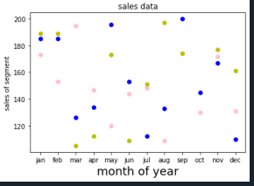

**4.Display the above data using multiline plot( 3 different lines in same graph)**

* **Display the description of the graph in upper right corner(use legend())**
* **Use different colors and line styles for 3 different lines**

import matplotlib.pyplot as plt

x1 = ['jan','feb','mar','apr','may','jun','jul','aug','sep','oct','nov','dec']

x2 = [173, 153, 195, 147, 120, 144, 148, 109, 174, 130, 172, 131]

plt.plot(x1, x2, color = 'hotpink', label = 'line 1', ls = '-.')

y1 = ['jan','feb','mar','apr','may','jun','jul','aug','sep','oct','nov','dec']

y2 = [189, 189, 105, 112, 173, 109, 151, 197, 174, 145, 177, 161]

plt.plot(y1, y2, color = 'y', label = 'line 2', linestyle = 'dashed')

z1 = ['jan','feb','mar','apr','may','jun','jul','aug','sep','oct','nov','dec']

z2 = [185, 185, 126, 134, 196, 153, 112, 133, 200, 145, 167, 110]

plt.plot(z1, z2, color = 'blue', label = 'line 3',linestyle = 'dotted')

plt.title("sales data")

plt.xlabel("Months")

plt.ylabel("sales of segments")

plt.legend()

plt.show()

1. **100 students were asked what their primary mode of transport for getting to school was. The results of this survey are recorded in the table below. Construct a bar graph representing this information.**

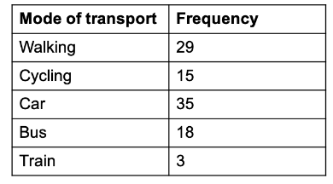

**Create a bar graph with**

* **X axis -mode of Transport and Y axis ‘frequency’**
* **Provide appropriate labels and title**
* **Width .1, color  green**

import matplotlib.pyplot as plt

import numpy as np

x = np.array(["Walking", "Cycling", "Car", "Bus", "Train"])

y = np.array([29, 15, 35, 18, 3])

plt.xlabel("mode of transport")

plt.ylabel("frequency")

plt.bar(x,y, color ="g", width = 0.1)

plt.show()

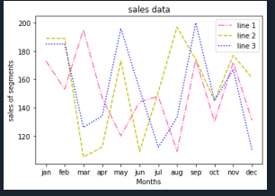

1. **We are provided with the height of 30 cherry trees.**

**The height of the trees (in inches): 61, 63, 64, 66, 68, 69, 71, 71.5, 72, 72.5, 73, 73.5, 74, 74.5, 76, 76.2, 76.5, 77, 77.5, 78, 78.5, 79, 79.2, 80, 81, 82, 83, 84, 85, 87.Create a histogram with a bin size of 5**

import matplotlib.pyplot as plt

height = [61, 63, 64, 66, 68, 69, 71, 71.5,

72, 72.5, 73, 73.5, 74, 74.5, 76,

76.2,76.5, 77, 77.5, 78, 78.5, 79,

79.2, 80, 81, 82, 83, 84, 85, 87]

plt.hist(height, edgecolor="red",bins=5)

plt.show()

